Population Growth

As we all know the population of world is increasing rapidly each year but at what extent and where our country lies on the scale ?

Here is my report on this growing population:

Population refers to the total number of people living in a region at a particular time.

There are currently 7.7 billion people on our planet. India itself has a population of 1.3 billion people. And the population of the world is rising steadily year on year. This increase in the population, i.e. the number of people inhabiting our planet is what we call population growth.

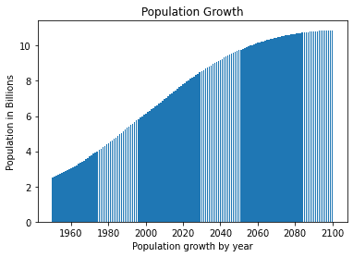This is the graph of population growth by past decades and predicted world’s population in upcoming years –

In 1950 there was around 2.2 billion peoples on our planet which grew to 7.7 billion by now and predicted to be grown to around 10 billions by 22nd century

As talking on world map the population density will look something like –

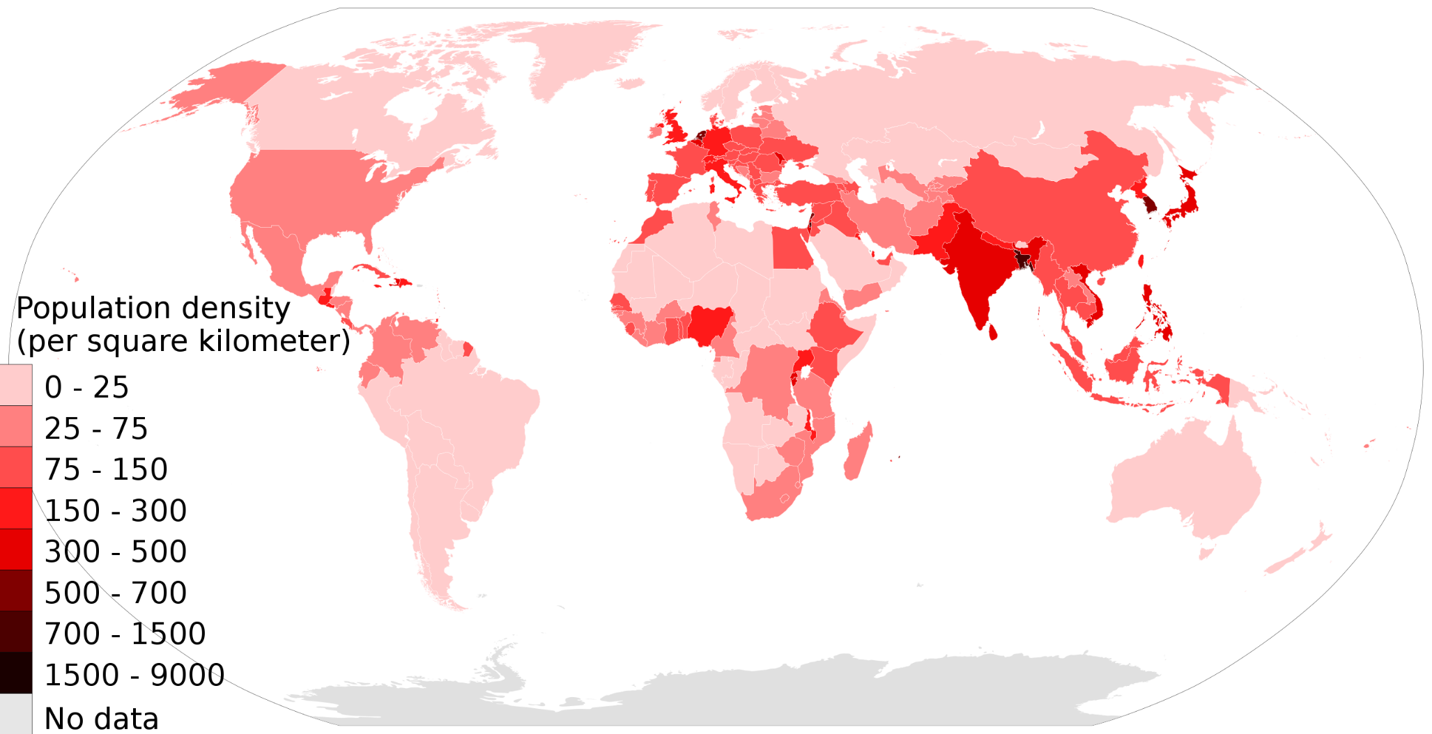

There is scale (heat readings) with which I showed you the comparative density of world’s population region wise .

On top of the population chart lies China and then India as highest populated countries.

As of 2022 the calculation of population of China is 1,450,584,104 and of India is 1,417,173,173 Combining total to have around 36% of world’s population

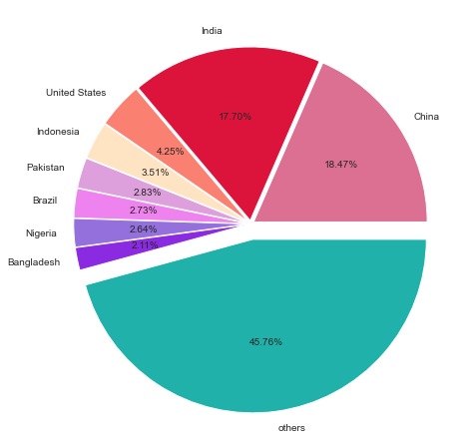

The top populated countries which have more than 2% of world’s population is shown in the figure

The land area is limited as also our natural resources which put us in huge concerns how our future will be. Where will we live as talking about area to live here is population density graph of 5 most populated countries.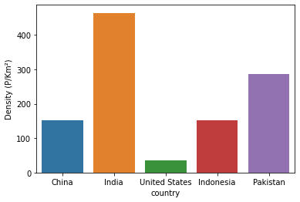

This clearly shows India is the densiest country having density of 464 persons per km2

United states a developed country has density only of 36 persons per km2

USA is 13 times less densier than India’s and china the most populated country is 3 times less densier than India. Which means India have very limited natural resources are compared to others

Fertility Rate –

The no. of children per couple is called fertility rate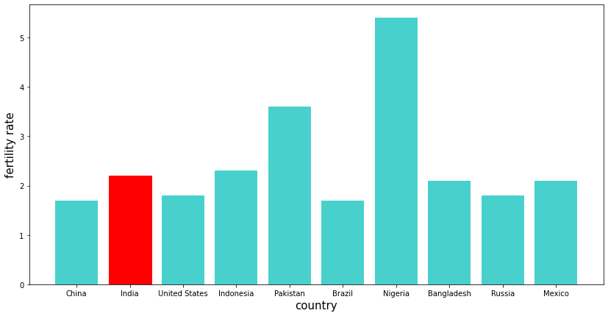

Fertility rate of India is 2.3 which is smaller than 2 i.e. the population is still increasing unlike China, which has fertility rate less than 2, government there made rules to control growth of their population. But there isn’t any written rule in India. China government imposed the one child policy in 1980 from the fear of overpopulation this step was taken.

But was then extended to 3 child limit in 1915. In India no such strong action was taken a bill was passed in 2019 for 2child policy but no rule was made.

With theses rate the population of India will be going to be around 1.7 billion in 2050 and 2.6 billion in 2100 which is not a good fact. 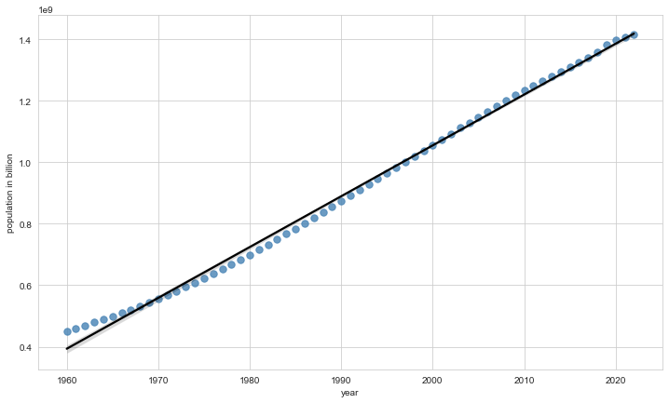

Population of India in last 62 years is shown in the above graph .

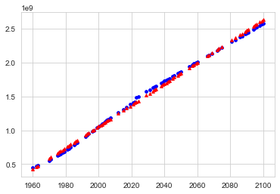

In this graph the blue dotted points are indicating the actual population growth till 2022 and after that the blue line predict population on present growth rate.

The red points are the prediction of population by regression or you can say by analysing the data of last 62 years and then predicting the population growth. Both are pretty close with a little variation

The percentage change in population can be visualised by :

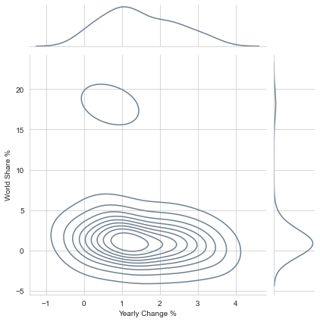

The graph shows the yearly change in growth of population, you can see there is much more diversity in lower part of graph which means that the countries with less population (less world share %) has more diversity in population growth. While in more populated countries there is some constant rate of change or you can say the growth is somehow constantly increasing, India and China stand on that plot. we can say India and China is more responsible for the Population explosion than any other country.

This is bad if population is not controlled there would be crisis. With population growth the density will also increase which means now more people have to adjust in that limited place which is a big hurdle in individual’s development and growth.

Beside this let see the urbanised population in top populated countries in the following graph :

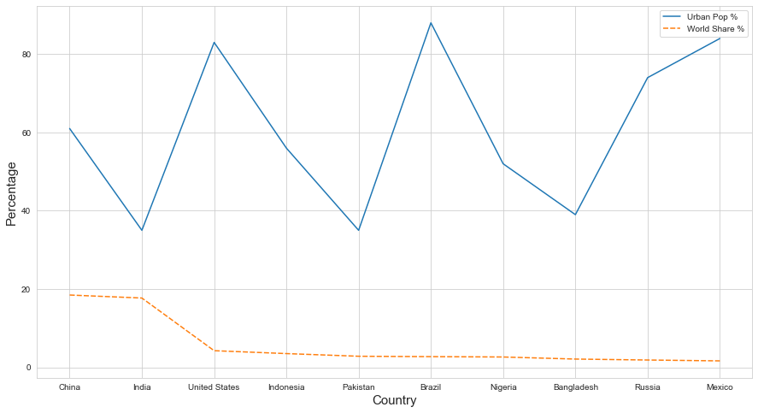

This shows that countries like India, Pakistan and Bangladesh majority population resides in unurbanized areas or in villages. Unlike other countries who have urbanised population in majority our country’s population is concentrated more in villages and small towns, theses areas don’t have enough facilities like Higher education (unavailability of good colleges) , multi specialised hospitals, shopping centres etc. which is a huge concern.

Let have a look on other insights too :

* The gender wise distribution of population in India over last 62 years :

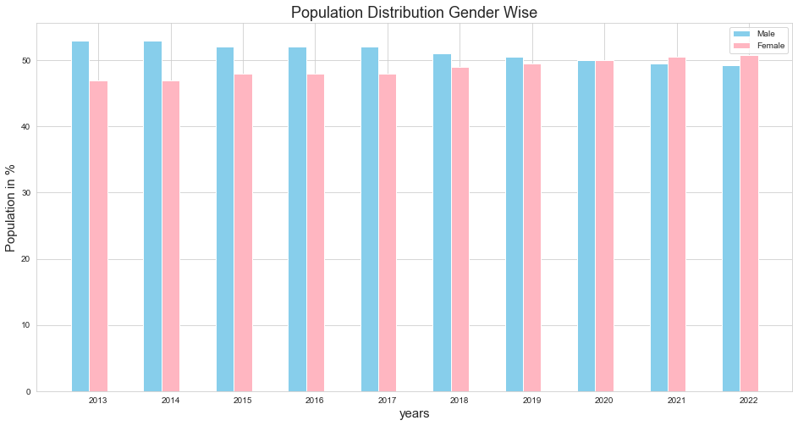

There is change in gender ratio over some last years in India, Female ratio is increased , now there are 1020 women for 1000 men in 2022. Back in 2001 it was- for 1000 men there were 943 women. The ideal gender ratio is 1:1 which creates perfect balance, but in real life ratios varies over years.

* The median age of top 10 populated countries : 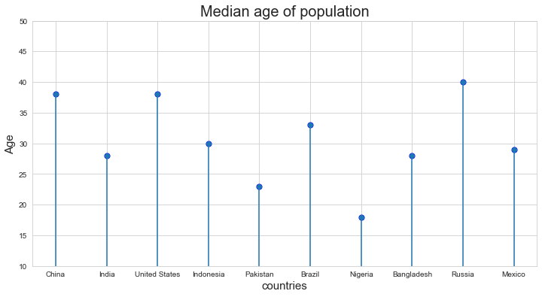

The median age of world’s population is 30 and India is close enough with 28. The median age depends on the age wise population distribution. And also has relation with fertility rate.

* The Age wise distribution of population in India over last 62 years -

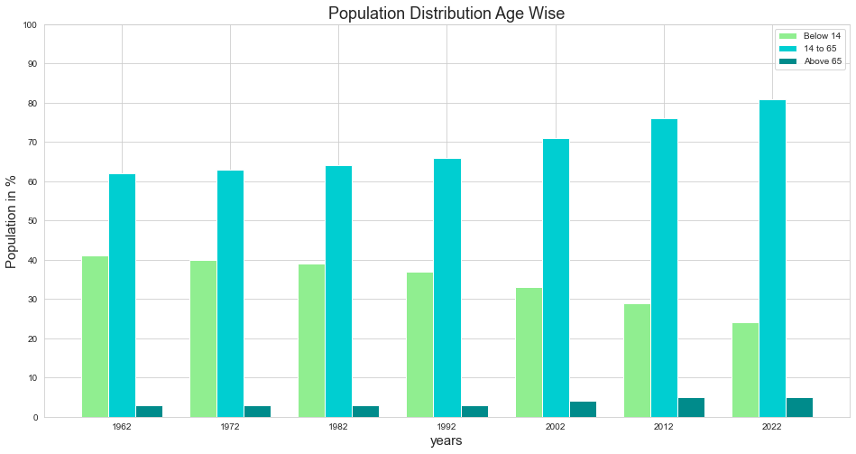

Comparing the first bar for 1962 with next bars, it’s a relief seeing that population below 14 year age group is decreasing throughout the time, which means fertility rate is decreased in last some decades that’s why population below 14 is less in 2022 from the previous decades. Also we can observe that as the fertility rate is decreasing the 14 to 65 category bar is increasing throughout. But still this is not enough the growth rate should be controlled further with more efficiency.